Wellbeing Policy  Caherea National School | 

Introduction
Caherea National School seeks to promote healthy lifestyles and the wellbeing of our school community, in a safe, supportive and non-threatening environment. Through our policies, procedures, activities and structures the school aims to create an environment in which:
- People feel valued
- Self-esteem is fostered
- There is respect, tolerance and fairness
- People in difficulty are supported
- There is open and honest communication
- Effort is recognised
- Difference and diversity are valued
- Conflict is handled constructively
- Social, moral and civic values are promoted
- Initiative and creativity are empowered
These aims are implemented in the daily transactions between management, staff, students and the wider school community.
This policy is drawn from Department’s Wellbeing Policy Statement and Framework for Practice 2018-2023 (revised in 2019) and as a follow on to the school’s SSE work on wellbeing from 2023 to 2025.

Definition of Wellbeing
This policy is guided by five key principles as outlined by the Wellbeing Policy Statement and Framework for Practice 2018-2023 (revised in 2019). These principles are that a Wellbeing Policy should be:
- Child/Young person-centred
- Equitable, fair and inclusive
- Evidence-informed
- Outcomes focused
- Partnership/Collaboration
The definition we draw on comes directly from this document:
“Wellbeing is present when a person realises their potential, is resilient in dealing with the normal stresses of their life, takes care of their physical wellbeing and has a sense of purpose, connection and belonging to a wider community. It is a fluid way of being and needs nurturing throughout life.”
This Wellbeing Policy document recognises that wellbeing does not necessarily mean the absence of stress or negative emotions in life or the absence of mental health difficulties and that everyone experiences vulnerability and a need for care at some stages in their journey through life. Wellbeing is a fluid way of being and needs nurturing throughout life.

Vision and Mission Statement
The wellbeing of the pupils and school community are embedded in and supported by our school’s vision and mission statement:
Vision
Our vision is to develop the skills and character in every pupil empowering them to meet, with assured confidence, the challenges of life now and in the future.
We actively promote the values of responsibility, perseverance, kindness, honesty and fairness.
Mission Statement
Our mission is to provide a model of primary education that reflects Ireland in the 21st Century. We celebrate the uniqueness of each child as expressed in each child’s personality, intelligence and potential for holistic development. We are committed to:
- helping pupils develop a lively enquiring mind,
- developing a sense of fair play, tolerance and respect towards other people and their views,
- creating a happy, stimulating and creative environment where children are keen to learn,
- developing a school in which the members of the community have confidence and feel welcome,
- providing high quality learning opportunities for all.

Context
This is a whole school policy which is informed by other policies, including the following:
- Code of Behaviour
- Bí Cineálta Anti-Bullying Policy
- SPHE Policy
- RSE Policy
- Homework Policy
- Digital Wellbeing
- Internet Acceptable Use Policy
- SEN Policy
- Child Protection Policy
- Critical Incident Policy
- Safety Statement

Indicators of Wellbeing
Six indicators of wellbeing have been identified. They are:
- Active: Being physically active is an Important element in staying well.
- Responsible: Each person must take responsibility for their own choices and make decisions which promote their own wellbeing and the wellbeing of others.
- Connected: It is important, for our wellbeing, to be connected to other people and to interact with others in a positive way. We should also appreciate the implications of our actions for those around us and further afield.
- Resilient: Everyone goes through challenges in their life. By building resilience, we hope to give our students the skills to cope with difficult situations.
- Respected: Feeling respected, listened to and cared for are key aspects of feeling well. Positive, respectful relationships are also central to maintaining our wellbeing.
- Aware: To stay well, we need to be aware of our thoughts, our emotions and our limitations. We should also be aware of those around us, conscious of how our actions might impact on their wellbeing.

Whole School Approach: Four Key Areas of Wellbeing Promotion
Caherea National School aims to provide a multicomponent approach to wellbeing promotion to ensure that all of the key areas that contribute to wellbeing promotion in schools are given a focus. These include:
Culture & Environment
- School vision and mission statement
- Restorative Practice methodologies
- Monthly assemblies
- School values and jewel jar rewards
- Holistic education approach
- Bright and child-centred school building
- Tidy and varied yard spaces
Curriculum: Teaching and Learning
- SPHE teaching
- PE teaching
- RSE and Stay Safe teaching
- Aistear
- Religious Education provision
- Use of varied and learning rich methodologies across subject areas
- Special education provision
- Planning and assessment
- Team-teaching
- Extra-curricular activities
- Support from OIDE and NEPS
- Promotion of special weeks throughout the school year

Policy and Planning
- Child is at the centre of decision-making process
- Policies as listed earlier
- Wellbeing as focus of School Self-Evaluation
- Professional development for staff in wellbeing areas

Relationships and Partnerships
- Student & staff relationships
- Greeting pupils each morning
- Sharing news daily
- Le Chéile time
- Student Council and student voice in the Junior Room
- Christmas concert and other community events
- Partnerships with the church, GAA club and local businesses

Actions to Promote the Wellbeing of a School Community
- Developing and maintaining a safe, caring culture and climate within the school where a sense of belonging and connectedness is fostered.
- Building positive relationships between teachers and children to promote participation, social interaction and pro-social behaviour.
- Adopting a whole-school approach to health promotion, where health is promoted by all and not just by a few members of staff.
- Actively involving children, their parents/guardians and the wider community in developing and implementing school policies to support mental health and health promotion.
- Supporting and implementing a well-planned, consistent and integrated SPHE curriculum to enable children enhance their coping, resilience, communication, conflict resolution, and problem-solving skills.
- Developing whole-school systems and structures to support the early identification of children experiencing social, emotional, behavioural or learning difficulties.
- Actively involving, supporting and encouraging children’s participation in extra-curricular activities.
- Fostering a whole-school ethos that accepts and values diversity within the pupil and staff population.
- Providing easy access to information for pupils and staff on supports available to them within the school and wider community.
- Facilitating access to continuing professional development for school staff on the promotion of the mental health and well-being of children.
The school has always placed a strong emphasis on the wellbeing of the school community. Through its policies and procedures, the school seeks to provide a safe, caring environment for all.

Staff Wellbeing
The wellbeing of school staff is also of extreme importance. As a school, we aim to support staff wellbeing through our policies, procedures and practices. These include:
- The promotion of a safe, comfortable teaching environment
- An open -door policy whereby staff can discuss issues of concern with the Principal and/or Deputy Principals in a confidential manner
- Regular staff meetings
- CPD is provided, encouraged and supported by the Board of Management
- Classes are resourced as well as possible. Requests for extra resources are considered and authorised, as appropriate
- Staff have the opportunity to develop their leadership capacity through various initiatives and responsibilities, and are supported in such.
- Staff social events are organised and supported by the Board of Management
- Staff are made aware of wellbeing supports through Spectrum Life.

Indicators of Success

In Caherea National School, we use the Wellbeing Indicators of Success to identify our strengths and targets for improvement, and to actively monitor our progress and outcomes in relation to wellbeing promotion over time. We achieve this by accessing the opinions and views of all stakeholders throughout the process. The Wellbeing Indicators of Success, outlined in Table 4, are the broad outcomes to which the Department aspires and wants schools and centres for education to accomplish.

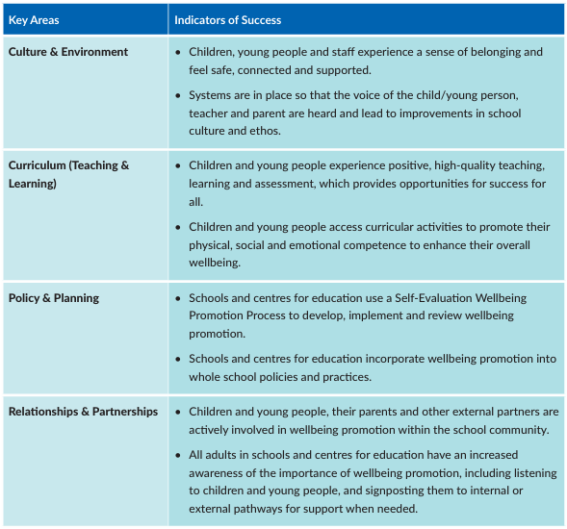

Monitoring and Review

The Principal and staff will monitor this policy regularly. Pupils will also be consulted, and informal observations will take place. Discussions with parents at Parent/Teacher meetings will aid the monitoring of the policy. The policy will be reviewed when deemed necessary by the Principal and Board of Management.

Ratification

This policy was ratified by the Board of Management of Caherea National School. A copy of the policy will be made available to staff and parents of the school. It will also be available on the school website.

Signed: Cora Kelly Chairperson, Board of Management

Signed: Maolíosa Quinn Principal

Date: 22.06.2026

